

MAJOR PROJECT REPORT ON

The Effect of Marketing-Operations Alignment on New Product Launches in the Consumer Goods Industry

By
TANISHA DEV
23173

In Partial Fulfilment for the award of the degree

Post Graduate Diploma in Management
Batch – 2023-2025
Specialization: Marketing and Operations & Supply Chain Management

New Delhi Institute of Management



New Delhi Institute of Management
50 (B&C), 60, Tughlakabad Institutional Area, New Delhi-110062
E-mail: placement@ndimdelhi.org
Website: www.ndimdelhi.org

MAJOR PROJECT REPORT ON

The Effect of Marketing-Operations Alignment on New Product Launches in the Consumer Goods Industry

Under the supervision
Of

Dr. Jyoti Kukreja

Submitted By-

Tanisha Dev
23173

DECLARATION

I Tanisha Dev student of New Delhi Institute of Management 2023-2025 Batch declare that every part of the Project Report on The Effect of Marketing-Operations Alignment on New Product Launches in the Consumer Goods Industry submitted by me is original.
I was in regular contact with my faculty guide and contacted several times to discuss the project.

Date of project submission:

Signature of the Student

CERTIFICATE OF AUTHENTICITY

Faculty Mentor’s Comments:

Signature of Faculty guide Name:

Dr. Jyoti Kukreja
Date:

ACKNOWLEDGEMENT

I am using this opportunity to express my deepest gratitude and special thanks to the New Delhi Institute of Management for providing me this opportunity of undertaking a research project during my final year of MBA in Marketing and Operations & Supply Chain Management.

I express my deepest thanks to Dr. Jyoti Kukreja ma'am faculty of NDIM. She allowed me to freely approach upon her precious time the beginning till the completion of my research project. Her guidance, encouragement, and suggestions provided me the necessary insight into my work and paved the way for the meaningful ending of the work at the right time.

Last but not the least my sincere thanks to all the staff members for their great help

Tanisha Dev
23173

EXECUTIVE SUMMARY

Coordination Between Marketing and Operations (MOA) is a critical factor in driving the success of introducing new products to the market in the sector of consumer products. This executive summary highlights the significance of aligning marketing and operations, the key factors influencing its effectiveness, and strategies for optimizing its impact on product launch success, expanding market presence, and overall business performance.

A well-coordinated marketing-operations strategy ensures that consumer demand insights from marketing teams are effectively translated into production, supply chain, and distribution processes. This alignment reduces inefficiencies, accelerates time-to-market, and enhances customer satisfaction. Companies that achieve a seamless collaboration between these functions experience higher success rates in product launches, improved brand positioning, and increased profitability.

Several factors influence the effectiveness of marketing-operations alignment. These include cross-functional communication, leadership support, technological integration, demand forecasting accuracy, and flexibility in supply chain operations. Organizations that foster strong collaboration between marketing and operations teams can reduce stockouts and overproduction, ensuring that product availability meets consumer expectations. However, poor alignment can lead to challenges such as delayed launches, misallocation of resources, and increased operational costs. Addressing these challenges requires strategic coordination and real-time data sharing across departments.

To maximize the benefits of marketing-operations alignment, organizations should implement structured collaboration frameworks, invest in data analytics for demand planning, and enhance interdepartmental communication. Utilizing technology-driven solutions such as Enterprise Resource Planning (ERP) systems and AI-driven demand forecasting tools can streamline workflows and improve decision-making. Additionally, fostering a culture of transparency, accountability, and adaptability is essential in ensuring alignment between marketing and operations teams.

Technology plays a pivotal role in enabling effective marketing-operations coordination. Digital tools for real-time inventory tracking, automated supply chain management, and predictive analytics allow companies to respond swiftly to market fluctuations. By leveraging these technological advancements, businesses can reduce lead times, enhance production efficiency, and optimize distribution networks to support successful introducing new products to the market.

Furthermore, ensuring alignment between marketing and operations requires a customer-centric approach. Consumer goods companies must integrate customer feedback loops, market research insights, and competitive analysis into their operational strategies. This ensures that product launches are data-driven, market-responsive, and aligned with evolving consumer preferences.

The ability to adapt to dynamic market conditions is key to sustaining competitive advantage in the sector of consumer products. Organizations that prioritize continuous improvement, innovation, and teamwork across different departments are better positioned to succeed in an increasingly competitive landscape.

In conclusion, marketing-operations alignment is a strategic imperative for driving successful introducing new products to the market. By implementing structured collaboration strategies, leveraging technology, and fostering an integrated organizational culture, companies can enhance product performance, optimize supply chain efficiency, and achieve long-term market leadership.

TABLE OF CONTENT

S.No. | Content |  | Page No.
1. | Introduction |  | 9-10
2. | Literature review |  | 11-13
3. | Relevance of study |  | 14
4. | Problem identification and study objectives |  | 15-16
5. | Research methodology |  | 17-18
6. | Data analysis |  | 19-34
7. | Recommendations |  | 35-36
8. | Conclusion |  | 37
9. | References |  | 38
10. | Annexure |  | 39-41

CHAPTER I – INTRODUCTION

Businesses are increasingly recognizing the importance of marketing-operations alignment (MOA) in driving successful introductions of new products to the market and fostering long-term business achievement. In today’s highly competitive sector of consumer products, MOA goes beyond merely ensuring collaboration between two departments; it represents a fundamental shift in how organizations integrate strategic marketing insights with streamlined business processes to meet consumer demand effectively. A well-aligned marketing and operations strategy contributes to faster time-to-market, optimized inventory management, and enhanced customer satisfaction, making it a key area of focus for both academic research and corporate strategy. Organizations that achieve this alignment can proactively respond to changing consumer needs, improve operational efficiency, and sustain competitive advantages. Moreover, with the rise of digital transformation and data-driven decision-making, MOA has become even more crucial in predicting market trends, ensuring production agility, and maximizing resource utilization.

The synchronization of marketing and operations has emerged as a critical factor in determining product launch success, market competitiveness, and overall business performance. As consumer preferences evolve and market dynamics shift rapidly, organizations are increasingly prioritizing teamwork across different departments to ensure that marketing strategies align seamlessly with production capabilities, supply chain logistics, and distribution networks. Businesses today seek not only to create innovative products but also to ensure efficient execution and timely market entry, minimizing risks such as delays, stockouts, or overproduction. Effective MOA allows businesses to identify customer demands early, translate them into actionable production plans, and adjust strategies based on real-time market feedback. Companies that successfully implement this alignment can reduce operational inefficiencies, improve cross-functional communication, and adapt quickly to external disruptions, such as supply chain bottlenecks or fluctuating raw material costs. This research aims to examine the impact of marketing-operations alignment on introducing new products to the market, identifying the key factors influencing its effectiveness and the challenges organizations face in achieving integration. Understanding these dynamics can provide valuable insights into how businesses can refine their processes to enhance productivity and profitability.

Successful product launches depend on a well-coordinated approach where marketing provides valuable consumer insights, demand forecasts, and competitive positioning strategies, while operations ensures efficient production planning, inventory control, and flexibility in supply chain operations. Research has shown a positive correlation between cross-functional alignment and key performance indicators such as time-to-market, product adoption rates, profitability, and customer loyalty. When implemented effectively, marketing-operations alignment can help organizations not only launch products more efficiently but also strengthen brand equity, expand market presence, and drive long-term profitability. Additionally, businesses that foster a collaborative culture between marketing and operations can enhance agility in responding to unforeseen challenges, ensuring resilience in dynamic markets. As technological advancements continue to reshape supply chain and marketing functions, leveraging tools such as artificial intelligence (AI), predictive analytics, and automated demand forecasting can further enhance the synchronization between these two critical domains.

Furthermore, the success of MOA depends on various internal and external factors, including communication strategies, leadership support, technology integration, and corporate agility. Organizations that effectively align marketing and operations can streamline workflows, enhance decision-making, and improve overall business performance. On the other hand, poor alignment can result in miscommunication, inventory imbalances, launch delays, and increased operational costs. Understanding these complexities is crucial for designing an integrated framework that benefits both business growth and consumer satisfaction. Additionally, fostering a culture of cross-functional collaboration requires structured processes, robust communication channels, and strong leadership commitment. Companies that invest in digital transformation initiatives, supply chain transparency, and customer-centric marketing approaches are more likely to succeed in integrating marketing and operations for superior business outcomes.

This research seeks to explore the role of marketing-operations alignment in introducing new products to the market, focusing on how leading consumer goods companies achieve cross-functional synergy, the challenges they encounter, and best practices for optimizing collaboration. By examining the relationship between marketing-operations coordination, product launch efficiency, and competitive advantage, this study aims to provide valuable insights into how businesses can create a more agile, customer-driven, and market-responsive product launch strategy. Furthermore, this research will analyze case studies of successful MOA implementations, evaluate the influence of technological innovations, and offer recommendations for companies looking to enhance their marketing and operations alignment. By addressing both theoretical and practical perspectives, this study will contribute to the broader understanding of how strategic integration between marketing and operations can drive long-term business success.

CHAPTER II – LITERATURE REVIEW

Literature Review: The Effect of Coordination Between Marketing and Operations on New Product Launches in the Consumer Goods Industry

- Cooper, R. G., & Kleinschmidt, E. J. (1995)
This research explores the drivers of successful introducing new products to the market, emphasizing the importance of cross-functional communication, shared KPIs, and synchronized decision-making. It identifies that organizations with aligned marketing and operations teams report higher profitability and stronger customer acceptance of new products. However, the study also points out the risks of poorly integrated teams, which may lead to misaligned production schedules and weak promotional strategies.

- Griffin, A., & Hauser, J. R. (1996)
Griffin and Hauser explore the importance of cross-functional teams in new product development, particularly the integration of marketing and operations. Their research indicates that companies with structured collaboration frameworks are more likely to meet launch deadlines, optimize inventory levels, and respond to consumer needs effectively. However, the study also highlights the need for robust communication channels to avoid conflicts arising from differing departmental priorities.

- Kahn, K. B., & Mentzer, J. T. (1998)
Kahn and Mentzer’s study highlights the role of cross-functional integration in supply chain and marketing efficiency. Their findings suggest that firms with integrated marketing-operations strategies experience lower costs, improved responsiveness, and enhanced brand loyalty. The study also emphasizes the need for technology adoption to facilitate real-time data sharing and improve coordination between departments.

- Calantone, R. J., & Di Benedetto, C. A. (2000)
Calantone and Di Benedetto examine how marketing-operations synchronization enhances product launch timing and competitiveness. Their research indicates that firms with seamless integration between market research and production planning reduce cost overruns and product failures. The study highlights the importance of real-time market feedback loops, allowing companies to adjust production and distribution strategies efficiently.

- Shapiro, B. P. (2002)
This study focuses on the strategic alignment of marketing and supply chain management in consumer goods firms. It finds that companies that synchronize demand forecasting, inventory planning, and promotional activities achieve higher product success rates. The research underscores the role of data-driven decision-making in enabling better coordination between marketing and operations, reducing the risk of stockouts or overproduction.

- Brown, S., & Blackmon, K. (2005)
This study examines the role of operational flexibility in marketing-driven product innovation. The authors find that firms with adaptive supply chain networks and dynamic manufacturing processes can quickly adjust to market demands, leading to higher success rates in introducing new products to the market. The research stresses the importance of aligning production schedules with promotional strategies to ensure optimal product visibility and availability.

- Ellinger, A. E., Keller, S. B., & Hansen, J. D. (2006)
This research examines how bridging the divide between logistics (operations) and marketing enhances overall business performance. The study suggests that companies with a collaborative approach to supply chain and marketing strategies can achieve greater expanding market presence and customer satisfaction. However, it warns that organizations with rigid silos between departments may struggle with miscommunication and inefficiencies, leading to delays in product launches. The authors recommend joint performance metrics and shared objectives to strengthen marketing-operations alignment.

- Swink, M., & Song, M. (2007)
This study investigates the impact of marketing-manufacturing integration on new product development (NPD), emphasizing its role in reducing time-to-market and enhancing competitive advantage. The findings reveal that firms with strong teamwork across different departments experience faster product launches and higher success rates, as marketing insights help operations anticipate demand and optimize production schedules. However, the study also highlights potential challenges, such as interdepartmental conflicts and misaligned performance metrics, which can hinder seamless integration.

- Slater, S. F., Hult, G. T. M., & Olson, E. M. (2010)
This study investigates how market orientation and streamlining business processes influence new product launch performance. The authors find that businesses with data-driven alignment between marketing strategies and supply chain capabilities achieve faster scalability, improved customer engagement, and higher revenue growth. The research also underscores the significance of technology in streamlining collaboration, recommending the use of predictive analytics and cloud-based supply chain management systems.

- Hillebrand, B., Nijholt, J. J., & Nijssen, E. J. (2011)
This research explores the relationship between marketing-operations collaboration and product launch success. The findings indicate that organizations with strong interdepartmental cooperation can reduce launch cycle times and improve product-market fit. However, challenges such as resistance to change, conflicting goals, and budget constraints can create barriers to alignment. The study recommends leadership-driven initiatives to foster a culture of collaboration.

- Roh, J., Hong, P., & Min, H. (2014)
This study examines how marketing-operations alignment impacts innovation and flexibility in supply chain operations in the consumer goods sector. The results show that companies with closely linked marketing and operational functions can adapt more swiftly to market changes, customer preferences, and supply chain disruptions. However, the study cautions against over-reliance on rigid processes, as they may reduce flexibility in responding to dynamic market demands.

- Kotler, P., & Keller, K. L. (2016)
Kotler and Keller’s work in Marketing Management provides foundational insights into how marketing strategies must be aligned with operational execution to drive product success. The research emphasizes that misalignment between demand generation (marketing) and fulfillment (operations) can lead to supply chain inefficiencies, excess inventory, and customer dissatisfaction. The study recommends a holistic, data-driven approach to integrating marketing and operations for successful new product introductions.

- Christopher, M. (2016)
Christopher’s research in Logistics & Supply Chain Management explores the role of supply chain efficiency in supporting marketing-driven product launches. The study identifies that companies leveraging agile supply chain practices can respond better to marketing-driven demand fluctuations, ensuring timely product availability and cost control. However, it cautions that lack of collaboration between marketing and operations teams can create bottlenecks, leading to delays and market entry failures.

CHAPTER III - RELEVANCY OF THE STUDY

This study contributes to the growing research on Coordination Between Marketing and Operations (MOA) and New Product Launches by addressing key gaps identified in the literature. While previous studies emphasize the importance of teamwork across different departments in improving product success rates, there is limited research on the specific mechanisms through which MOA influences product launch efficiency and expanding market presence in the sector of consumer products. This study will analyze how marketing-operations synchronization impacts time-to-market, demand forecasting accuracy, and flexibility in supply chain operations, providing industry-specific insights.

Another critical gap observed is the role of leadership and interdepartmental coordination in the success of MOA. While strategic alignment is known to enhance streamlining business processes and brand positioning, its effectiveness depends on corporate culture, communication frameworks, and managerial collaboration. This research will explore how different leadership styles and organizational structures influence the success of marketing-operations integration, particularly in fast-moving consumer goods (FMCG) and retail sectors. Additionally, the impact of technology-driven decision-making in facilitating marketing-operations coordination remains underexplored. The study will assess whether advanced data analytics, AI-based demand forecasting, and digital supply chain tools enhance or hinder cross-functional alignment, helping companies optimize new product development (NPD) strategies.

Furthermore, challenges related to resource allocation, performance measurement, and interdepartmental conflicts in MOA require attention. Many studies indicate that misalignment between marketing-driven demand creation and operational execution leads to inefficiencies, increased costs, and product launch failures. This research will provide recommendations on developing integrated performance metrics, enhancing interdepartmental communication, and leveraging real-time data-sharing platforms to ensure seamless coordination.

By addressing these gaps, this study will offer practical strategies for business leaders, supply chain professionals, and marketing strategists to create sustainable and effective marketing-operations alignment models that enhance product launch success, competitive positioning, and overall business growth.

CHAPTER IV - PROBLEM IDENTIFICATION AND STUDY OBJECTIVES

Problem Identification:
Achieving successful introducing new products to the market has become a significant challenge for organizations in the sector of consumer products, where competition is intense, and market dynamics are constantly evolving. Many companies face difficulties in aligning marketing strategies with operational capabilities, leading to issues such as delayed product releases, supply chain inefficiencies, and poor expanding market presence. The lack of seamless coordination between marketing and operations teams often results in misaligned production schedules, excess inventory, or stock shortages, impacting both customer satisfaction and profitability.

Despite the recognized benefits of marketing-operations alignment (MOA), its implementation remains a complex and underexplored area. Many organizations struggle with cross-functional communication barriers, conflicting departmental objectives, and inadequate performance measurement systems, which hinder efficient decision-making and execution. Additionally, there is a lack of industry-specific insights on how MOA affects new product development and market success in different segments of the sector of consumer products, such as fast-moving consumer goods (FMCG), luxury goods, and packaged consumer products.

Furthermore, technology and data analytics play a crucial role in enhancing MOA, but their impact on product launch efficiency and operational responsiveness is still not well understood. While digital tools such as ERP systems, AI-driven demand forecasting, and real-time inventory tracking can improve collaboration, companies often face challenges in integrating these technologies effectively. Additionally, resistance to organizational change, siloed decision-making, and the absence of standardized processes create obstacles to seamless alignment between marketing and operations teams.
Given these challenges, it is essential to explore how organizations can effectively integrate marketing and operations functions to optimize introducing new products to the market, minimize inefficiencies, and maximize market success. This study seeks to identify the key factors influencing MOA, providing organizations with actionable insights on how to improve teamwork across different departments and ensure smoother, more efficient product rollouts.

Study Objectives :
Based on the problem identification, this study is guided by the following objectives:

To examine the impact of marketing-operations alignment (MOA) on the success rate, expanding market presence, and profitability of introducing new products to the market in the sector of consumer products.

To analyze the role of leadership, interdepartmental communication, and organizational structure in facilitating seamless marketing-operations collaboration.

To explore the challenges and limitations of MOA, including misaligned goals, inefficient resource allocation, and operational bottlenecks.

To assess the influence of technology and data analytics in improving MOA and enhancing new product development (NPD) strategies.

To evaluate the impact of flexibility in supply chain operations, demand forecasting accuracy, and production efficiency on MOA effectiveness.

To provide practical recommendations for organizations to develop structured, data-driven, and well-communicated MOA strategies that enhance product launch efficiency, customer satisfaction, and business growth.

By achieving these objectives, this study will offer valuable insights for business leaders, marketing strategists, and supply chain professionals to enhance MOA frameworks, streamline introducing new products to the market, and gain a competitive advantage in the consumer goods market.

CHAPTER V - RESEARCH METHODOLOGY

- SAMPLING TECHNIQUE

- Creation of Google Form:
- Develop a structured Google Form with well-defined questions targeting the impact of Coordination Between marketing-operations alignment (MOA) on New Product Launches in the sector of consumer products.
- Include a mix of Likert-scale questions, multiple-choice options, and open-ended questions to collect both quantitative and qualitative insights.
- The study will focus on 50 professionals from the sector of consumer products, including marketing managers, operations managers, supply chain professionals, and product development executives. A random sampling method will be used to ensure a diverse representation of professionals with varying roles, experience levels, and involvement in introducing new products to the market.

B. Diverse Participant Recruitment:
- Ensure participation from marketing and operations professionals across different segments of the sector of consumer products, including FMCG, packaged goods, luxury products, and retail.
- Distribute the Google Form using emails, LinkedIn, industry groups, and professional networks to encourage participation.

C. Encouraging Participation:
- Clearly explain the objective of the study and how responses will contribute to understanding the role of MOA in product launch success.
- Maintain confidentiality to encourage honest responses.
- Provide small incentives (if feasible) to motivate participation and ensure a high response rate.

- Methodology and Sample Size

- A 15-question questionnaire was developed to measure the impact of MOA on the success of introducing new products to the market.
- The survey was distributed to 55 professionals across the sector of consumer products to ensure diversity in responses.
- Participants were selected randomly, ensuring representation from different job roles, company sizes, and market segments.

The questionnaire focused on:
- The degree of collaboration between marketing and operations teams in product launches.
- The effect of MOA on time-to-market, inventory management, and supply chain efficiency.
- Challenges faced due to misalignment between marketing and operations.
- Suggestions for improving interdepartmental collaboration in product launches.

- Sources of Research

A. Primary Data:
- Collected via Google Forms through a structured survey of 50 professionals.
- Data includes insights from marketing and operations executives, engagement levels, and experiences with introducing new products to the market.

B. Secondary Data:
- Company reports, industry white papers, academic journals, and case studies were reviewed.
- Analysis of global trends in MOA and best practices for successful product launches from leading consumer goods companies (e.g., P&G, Unilever, Nestlé, and Coca-Cola).

- Data Collection Method: Structured Surveys via Google Form

A. Questionnaire Design:
- The survey was structured to measure the role of MOA in new product launch performance.
- Ensured clarity and relevance of questions to avoid ambiguity.
- Sections included:
- General demographic details (job role, industry segment, company size).
- Marketing-operations collaboration in product launch planning and execution.
- Impact of MOA on inventory management, flexibility in supply chain operations, and demand forecasting.
- Challenges in MOA and potential solutions.
- Open-ended feedback on best practices and recommendations for improving MOA.

B. Quantitative Data Collection:
- Multiple-choice questions assessed the degree of MOA implementation in consumer goods companies.
- Checkboxes were used to identify common challenges in marketing-operations collaboration.
- Descriptive statistics and correlation analysis will be used to identify trends in MOA and product launch success.

By employing this methodology, the study will provide valuable insights into how marketing-operations alignment influences introducing new products to the market, offering actionable recommendations for improving teamwork across different departments in the sector of consumer products.

CHAPTER VI - DATA ANALYSIS AND INTERPRETATION

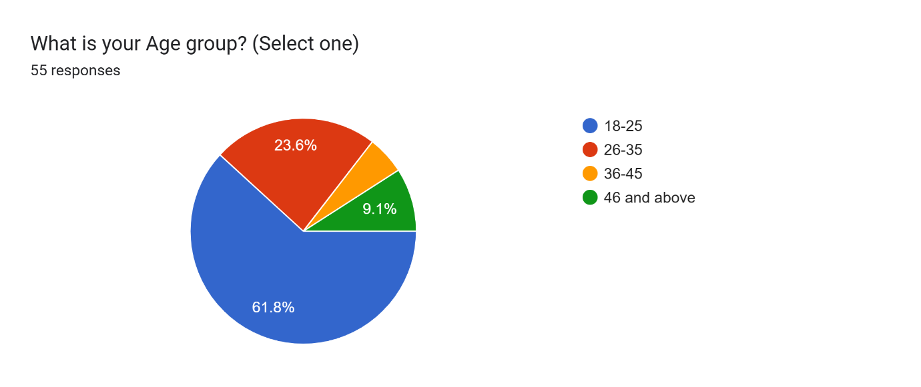

Interpretation

Distribution of Respondents by Age Group

The pie chart shows the age distribution of the 55 participants in this study. The largest number of participants (61.8%) are between 18-25 years, and thus are the most prevalent age group. The 26-35 age group makes up 23.6% of the participants, and 36-45 years make up a smaller percentage of 9.1%. The least represented category is 46 years and older, making up a very small percentage of the participants. This distribution implies that young people, especially those in the 18-25 years age group, make up the larger sample population for this study, and depending on the research location, can have an impact on the overall outcome.

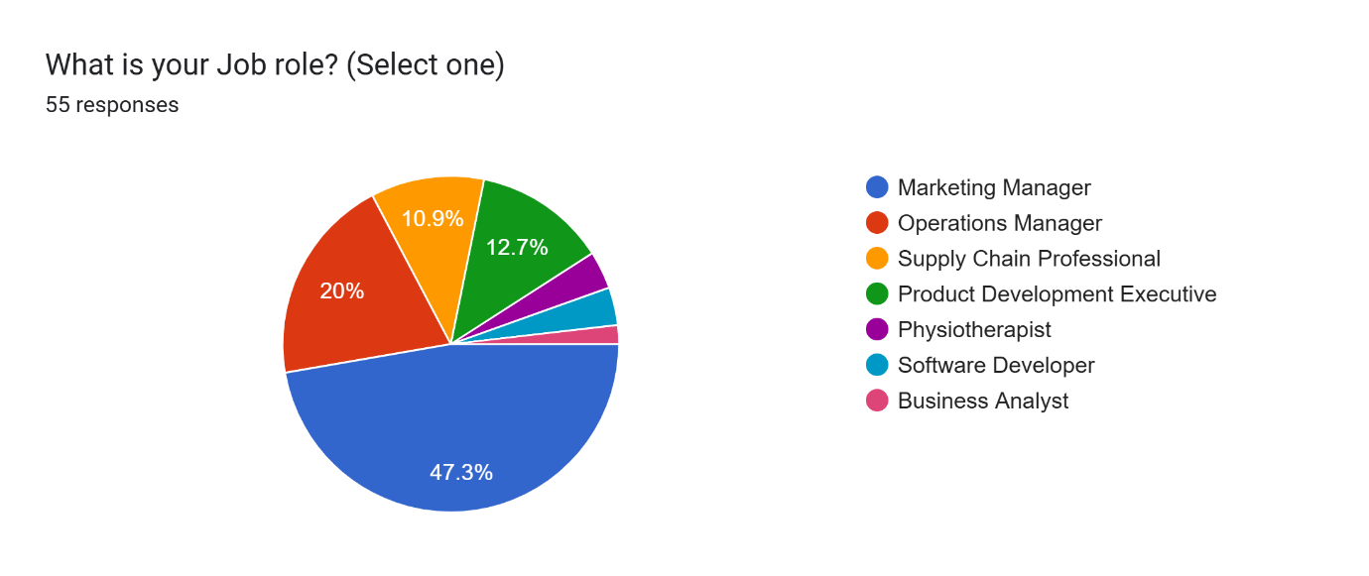

Interpretation

Distribution of Respondents by Job Role

The pie chart indicates the distribution of job roles among the 55 participants. Most of the participants, 47.3%, belong to the job role of Marketing Managers, which means nearly half of the sample consist of individuals from this profession. Operations Managers account for 20% of the participants, Supply Chain Professionals 10.9%, and Product Development Executives 12.7%. All the remaining jobs, including Physiotherapists, Software Developers, and Business Analysts, are underrepresented in the data set. This means conclusions from the survey may be more representative of marketing and operations opinions since they have a higher response rate.

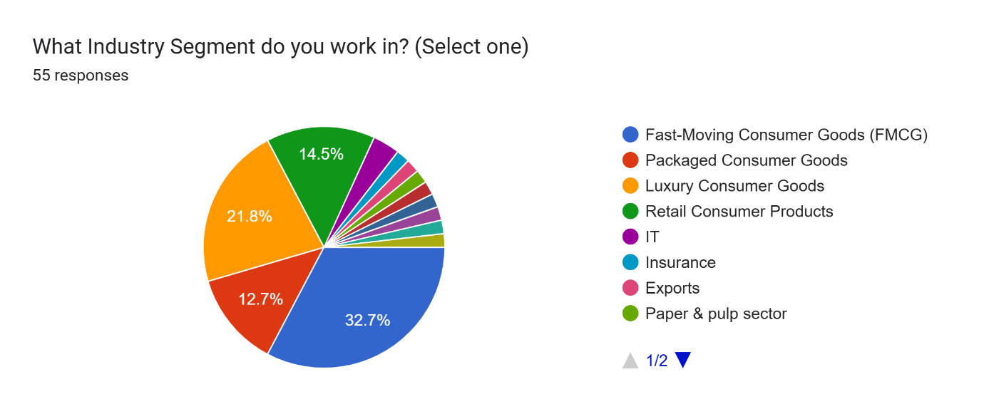

Interpretation

Industry Segment Distribution of Respondents

The pie chart shows the segmentation of the respondents across industry segments. The largest percentage, 32.7%, is from the Fast-Moving Consumer Goods (FMCG) industry, and it is the most represented industry in the study. The Luxury Consumer Goods industry is next with 21.8%, followed by Retail Consumer Products with 14.5%. Packaged Consumer Goods has 12.7% of the respondents. Other industries, such as IT, Insurance, Exports, and the Paper & Pulp industry, have a relatively lower presence. This segmentation implies that findings of this study might be more representative of the consumer goods industry, especially FMCG and luxury goods, due to their higher response rates.

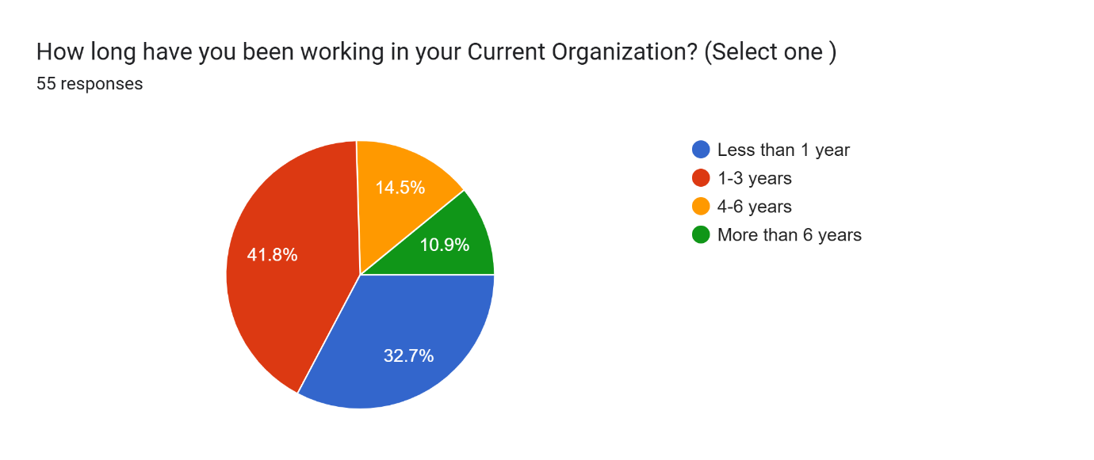

Interpretation

Tenure of Respondents in Their Current Organization

The pie chart represents the duration for which respondents have been working in their current organization. The highest proportion, 41.8%, have been with their organization for 1-3 years, suggesting a significant portion of the workforce is relatively new but has gained some experience. 32.7% of respondents have been in their current roles for less than a year, indicating a notable presence of recently hired employees. Meanwhile, 14.5% have a tenure of 4-6 years, and 10.9% have been with their organization for more than 6 years. This distribution implies that the majority of participants have relatively short to mid-term experience within their current organization, which may influence perspectives on organizational culture, job satisfaction, and professional growth.

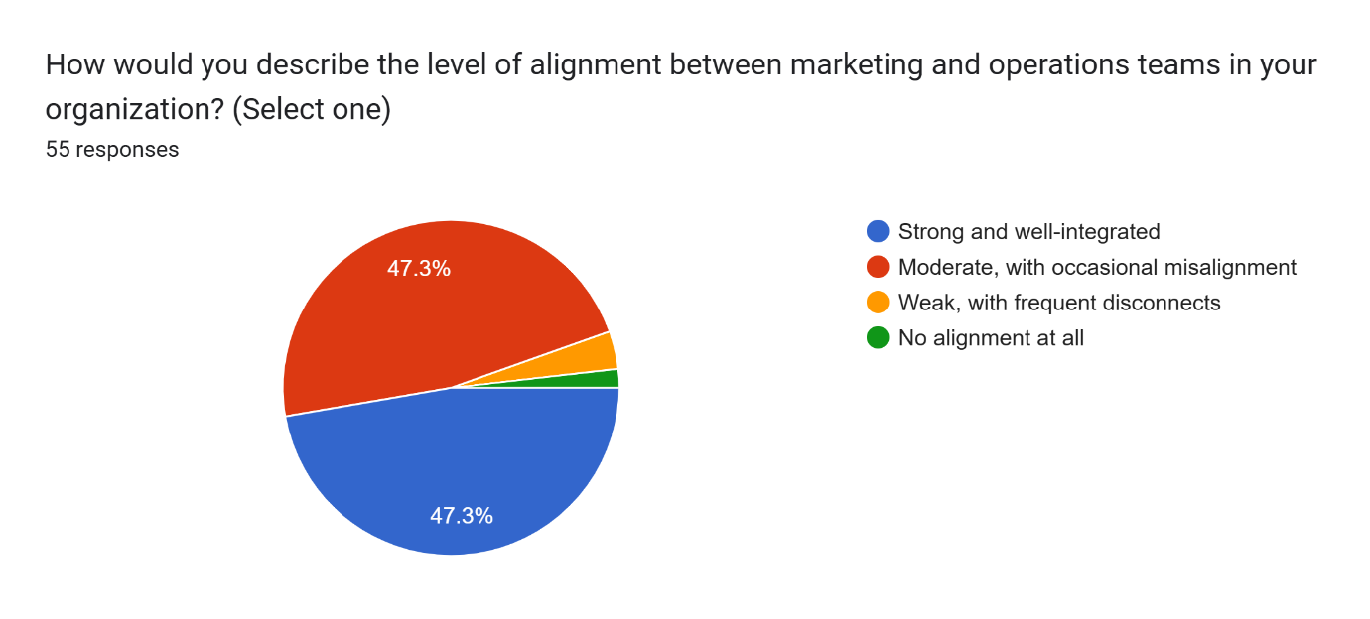

Interpretation

Alignment Between Marketing and Operations Teams

The pie chart illustrates the perceived level of alignment between marketing and operations teams within respondents’ organizations. The responses are evenly split between "Strong and well-integrated" (47.3%) and "Moderate, with occasional misalignment" (47.3%), indicating that while nearly half of the respondents feel their teams collaborate effectively, an equal proportion experiences some level of misalignment. A smaller fraction, 4.5%, describes the alignment as "Weak, with frequent disconnects," while an even smaller percentage reports "No alignment at all." These findings suggest that while a majority of organizations have a functional working relationship between marketing and operations, there is still room for improvement in ensuring seamless collaboration and minimizing occasional misalignment.

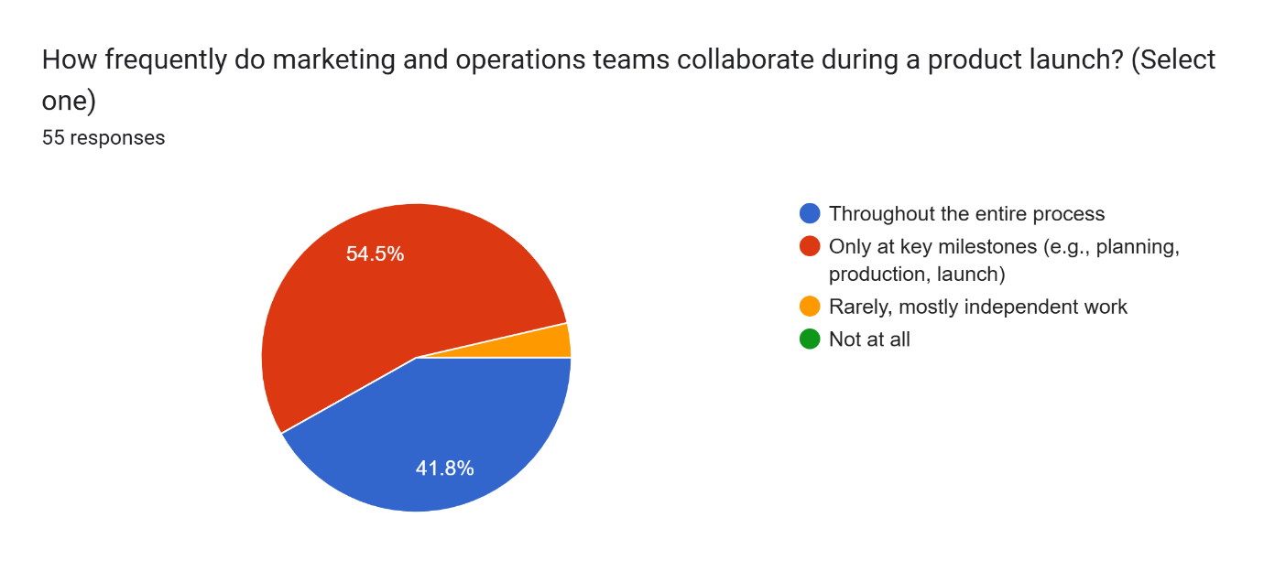

Interpretation

Collaboration Between Marketing and Operations Teams During a Product Launch

The pie chart illustrates the frequency of collaboration between marketing and operations teams during a product launch. The majority of respondents (54.5%) indicate that collaboration occurs only at key milestones such as planning, production, and launch. Meanwhile, 41.8% report that these teams work together throughout the entire process, suggesting a more integrated approach. A small fraction of respondents (3.6%) state that collaboration is rare, with each team working mostly independently, and no respondents reported a complete lack of collaboration.
These findings suggest that while marketing and operations teams generally engage with each other during critical phases of a product launch, continuous collaboration is less common. Organizations aiming for more seamless product rollouts may benefit from fostering ongoing coordination between these teams rather than limiting interaction to key milestones.

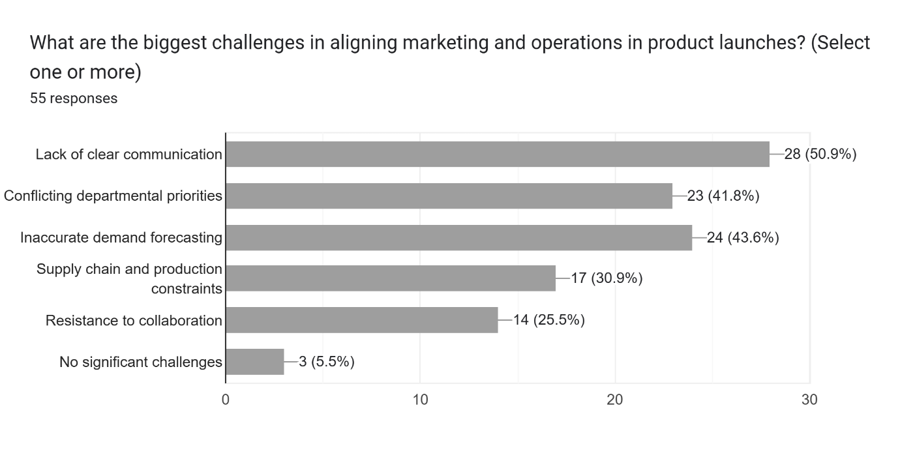

Interpretation

Challenges in Aligning Marketing and Operations in Product Launches

The bar chart highlights the biggest challenges faced in aligning marketing and operations teams during product launches. The most frequently reported challenge is "Lack of clear communication" (50.9%), indicating that ineffective information flow is a significant barrier to collaboration. "Inaccurate demand forecasting" (43.6%) and "Conflicting departmental priorities" (41.8%) are also major issues, suggesting that differences in objectives and forecasting inefficiencies contribute to misalignment.
Additionally, "Supply chain and production constraints" (30.9%) and "Resistance to collaboration" (25.5%) further hinder effective teamwork. Notably, only 5.5% of respondents reported "No significant challenges," reinforcing that most organizations face some degree of difficulty in ensuring seamless coordination between these departments.
These findings suggest that improving communication channels, aligning priorities, and refining forecasting methods could significantly enhance collaboration between marketing and operations teams in product launches.

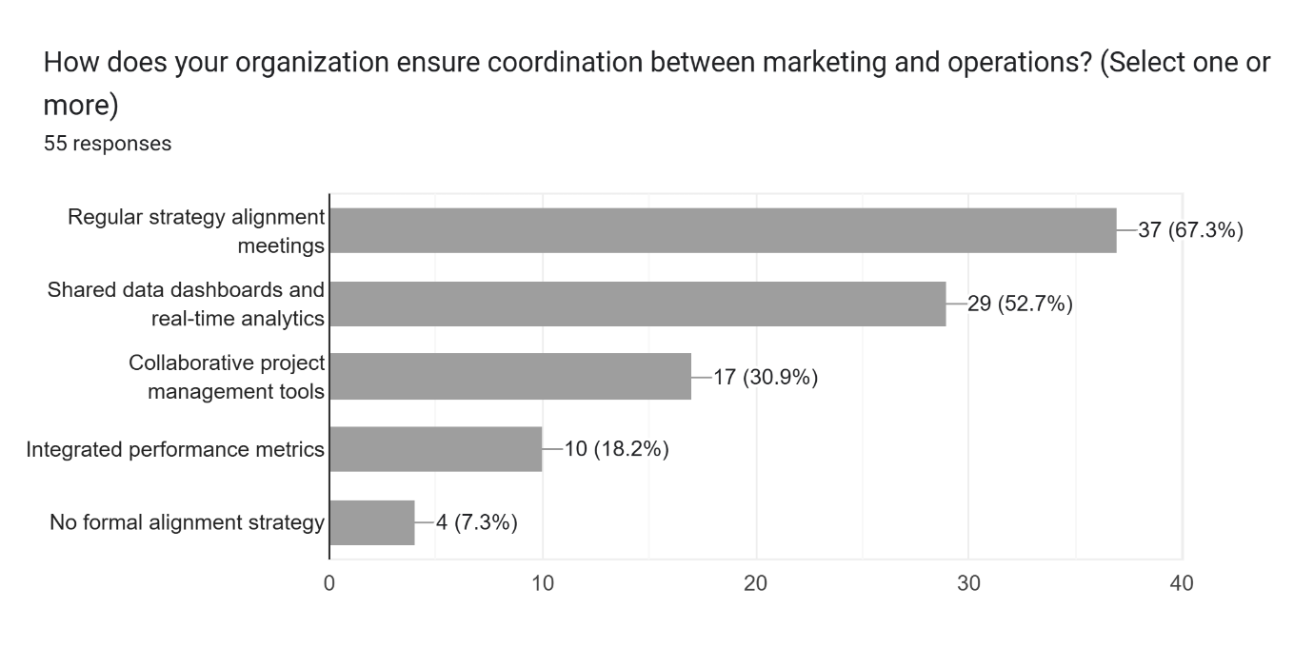

Interpretation

Coordination Strategies Between Marketing and Operations

The bar chart illustrates the various strategies organizations use to ensure coordination between marketing and operations teams. The most common approach, reported by 67.3% of respondents, is regular strategy alignment meetings, indicating that scheduled discussions play a key role in fostering collaboration. Additionally, 52.7% of participants highlight the use of shared data dashboards and real-time analytics, emphasizing the importance of data-driven decision-making in maintaining alignment.
Other methods include collaborative project management tools (30.9%) and integrated performance metrics (18.2%), showing that some organizations leverage technology and structured performance tracking to enhance coordination. However, 7.3% of respondents report having no formal alignment strategy, suggesting that a small portion of organizations lack structured coordination efforts.
These findings suggest that while most organizations implement structured coordination mechanisms, there is room for improvement, particularly in integrating project management tools and performance metrics to strengthen cross-functional collaboration.

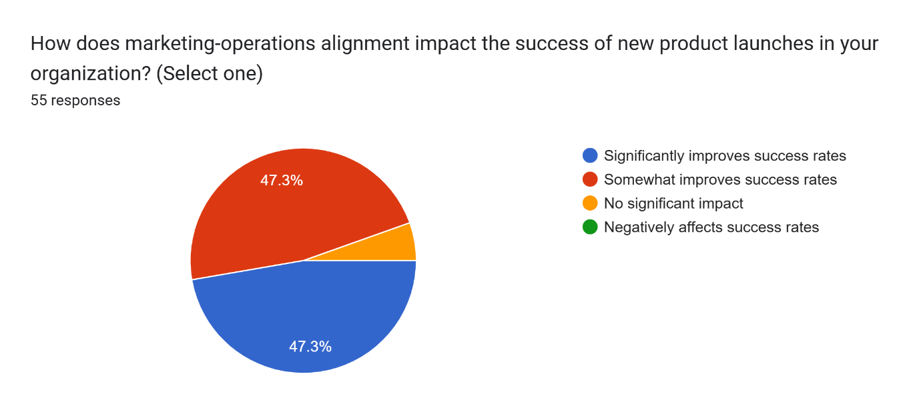

Interpretation

Impact of Marketing-Operations Alignment on Product Launch Success

The chart illustrates the perceived impact of marketing-operations alignment on the success of new product launches. 47.3% of respondents believe that strong alignment significantly improves success rates, while an equal percentage (47.3%) indicate that it somewhat improves success rates. This suggests that nearly all respondents recognize the importance of cross-functional collaboration in ensuring successful product launches.
A small proportion of respondents (5.4%) believe that alignment has no significant impact, while 0% reported that it negatively affects success rates. These findings reinforce the notion that effective coordination between marketing and operations plays a crucial role in driving successful product introductions, with a strong emphasis on the positive correlation between alignment and performance outcomes.

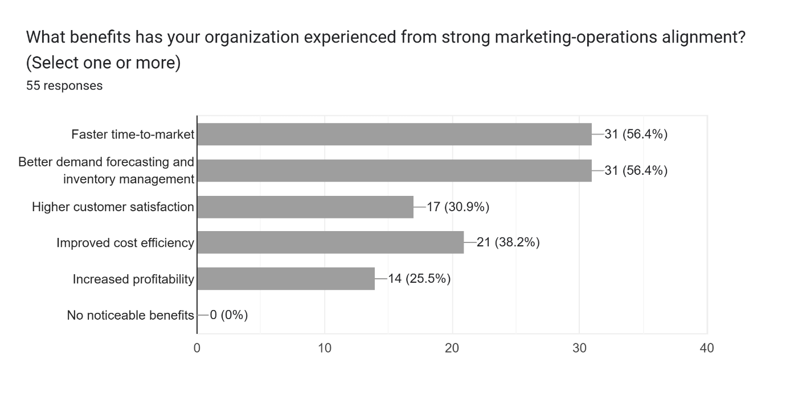

Interpretation

Benefits of Strong Marketing-Operations Alignment

The chart highlights the key benefits organizations have experienced due to strong marketing-operations alignment. The most commonly reported advantages include:
- Faster time-to-market (56.4%)
- Better demand forecasting and inventory management (56.4%)
These top two benefits indicate that streamlined collaboration enables companies to react swiftly to market demands and optimize their supply chains efficiently.
Other significant benefits include:
- Higher customer satisfaction (30.9%)
- Improved cost efficiency (38.2%)
- Increased profitability (25.5%)
Notably, 0% of respondents reported no noticeable benefits, reinforcing the consensus that marketing-operations alignment contributes positively to organizational performance.
These findings suggest that fostering collaboration between these teams can drive both operational excellence and customer-centric outcomes, ultimately leading to competitive advantages.

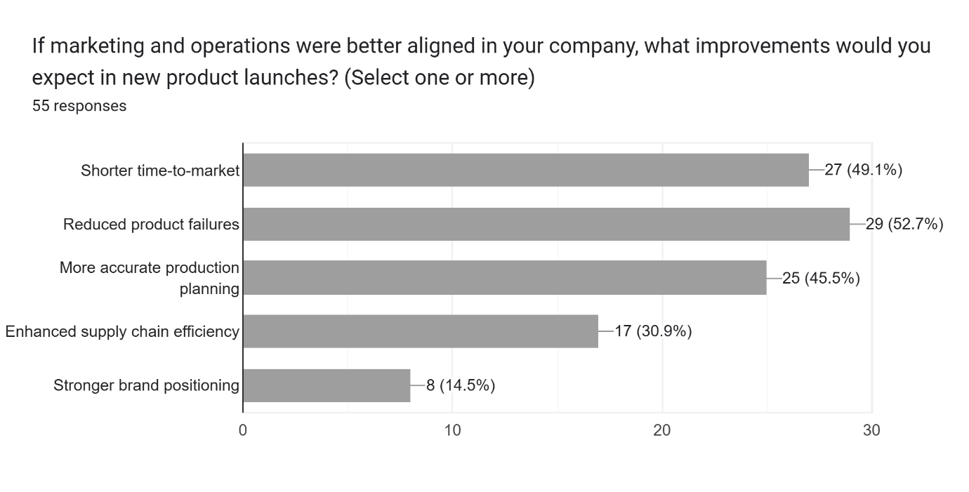

Interpretation

Expected Improvements with Better Marketing-Operations Alignment

The chart outlines the key improvements respondents anticipate if marketing and operations were better aligned. The top expected benefits include:
- Reduced product failures (52.7%) – Better coordination can lead to higher quality products and fewer launch issues.
- Shorter time-to-market (49.1%) – Streamlined collaboration enables faster execution of product launches.
- More accurate production planning (45.5%) – Improved forecasting and alignment can lead to better resource allocation.
Additional expected improvements include:
- Enhanced supply chain efficiency (30.9%) – Strengthened coordination can help reduce bottlenecks and optimize logistics.
- Stronger brand positioning (14.5%) – A unified approach between marketing and operations may lead to more cohesive branding and messaging.
These findings emphasize that stronger integration between these teams can drive both operational efficiency and market success.

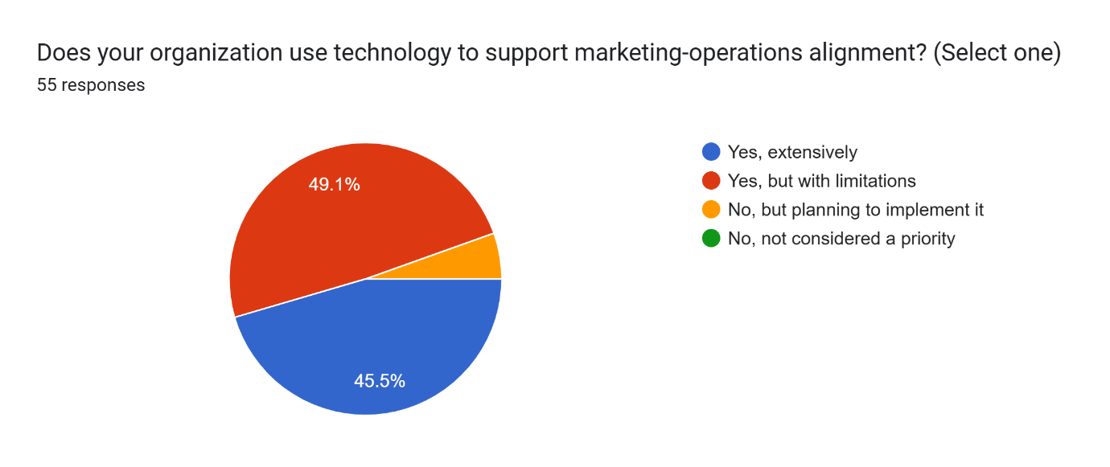

Interpretation

Technology Usage for Marketing-Operations Alignment

The survey results indicate how organizations are leveraging technology to enhance coordination between marketing and operations:
- 45.5% of respondents use technology extensively, suggesting a strong reliance on digital tools to facilitate collaboration.
- 49.1% report using technology but with limitations, indicating that while tools are in place, they may not be fully optimized or integrated.
- A small portion of respondents are either planning to implement technology or do not consider it a priority.
These insights suggest that while many organizations recognize the importance of technology in alignment, there is room for improvement in maximizing its effectiveness. Investing in more integrated tools could enhance communication, forecasting, and overall efficiency.

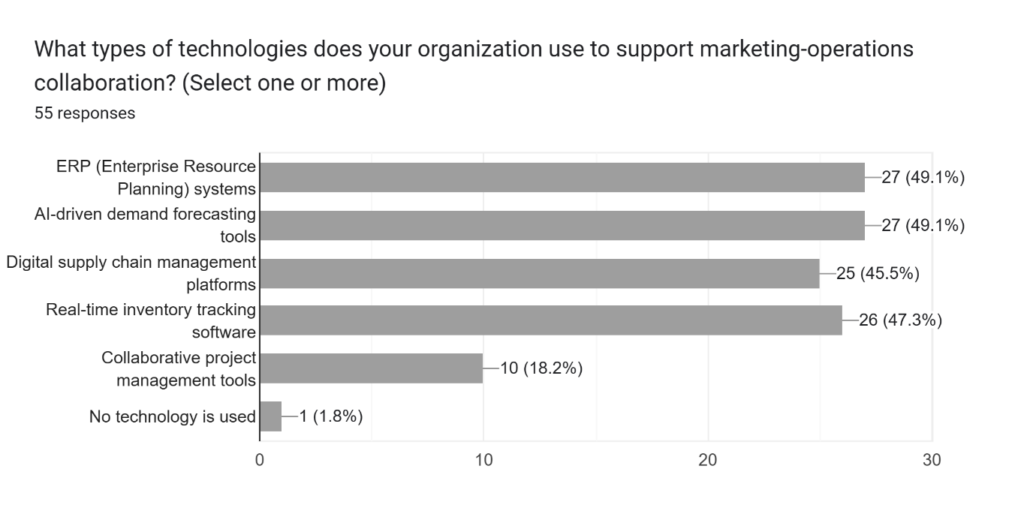

Interpretation

Technology Adoption for Marketing-Operations Collaboration

The survey results highlight the types of technologies organizations use to facilitate collaboration between marketing and operations:
- ERP (Enterprise Resource Planning) systems (49.1%) and AI-driven demand forecasting tools (49.1%) are the most widely used, showing a focus on integrated planning and predictive analytics.
- Real-time inventory tracking software (47.3%) and digital supply chain management platforms (45.5%) are also popular, indicating the importance of real-time visibility and efficient logistics coordination.
- Collaborative project management tools (18.2%) have lower adoption, suggesting that structured project-based collaboration may not be as emphasized.
- A very small percentage (1.8%) reported using no technology at all, showing that most organizations recognize the value of digital tools in alignment efforts.
Organizations are prioritizing data-driven and automated solutions to enhance cross-functional collaboration. However, improving the use of collaborative tools and integrating these technologies further could streamline workflows and improve efficiency.

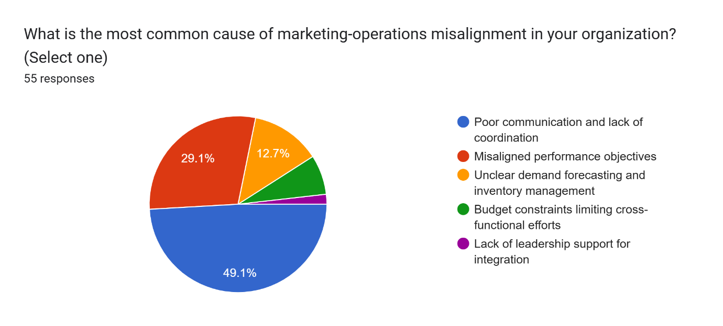

Interpretation

Common Causes of Marketing-Operations Misalignment

The survey results indicate the key reasons for misalignment between marketing and operations in organizations:
- Poor communication and lack of coordination (49.1%) is the most significant challenge, highlighting the need for structured collaboration and transparency.
- Misaligned performance objectives (29.1%) suggest that teams may have conflicting goals, leading to inefficiencies and delays.
- Unclear demand forecasting and inventory management (12.7%) indicate that data-driven decision-making could be improved.
- Budget constraints (small percentage) and lack of leadership support (very minimal impact) show that financial and executive backing are less frequently cited barriers.
Addressing communication gaps, aligning goals, and enhancing demand forecasting processes should be priorities for improving marketing-operations collaboration.

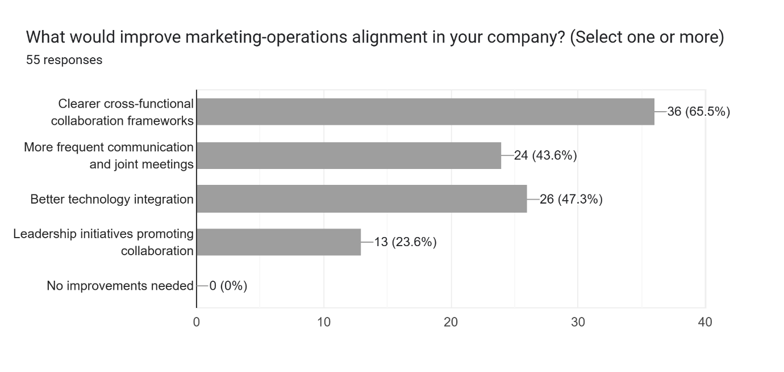

Interpretation

Key Improvements for Marketing-Operations Alignment

The survey responses highlight the most impactful strategies for enhancing alignment between marketing and operations:
- Clearer cross-functional collaboration frameworks (65.5%): Establishing structured processes for collaboration is the most sought-after improvement.
- Better technology integration (47.3%): Organizations recognize the need for seamless data-sharing and automated workflows.
- More frequent communication and joint meetings (43.6%): Regular touchpoints can help bridge gaps and align objectives.
- Leadership initiatives promoting collaboration (23.6%): Strong leadership backing is necessary but less emphasized compared to other factors.
- No improvements needed (0%): Every respondent acknowledges room for improvement.
Actionable Next Steps
- Implement structured cross-functional collaboration processes to streamline workflows.
- Invest in technology that facilitates real-time data sharing and project tracking.
- Schedule regular joint meetings between marketing and operations teams.
- Encourage leadership-driven initiatives to reinforce alignment efforts.

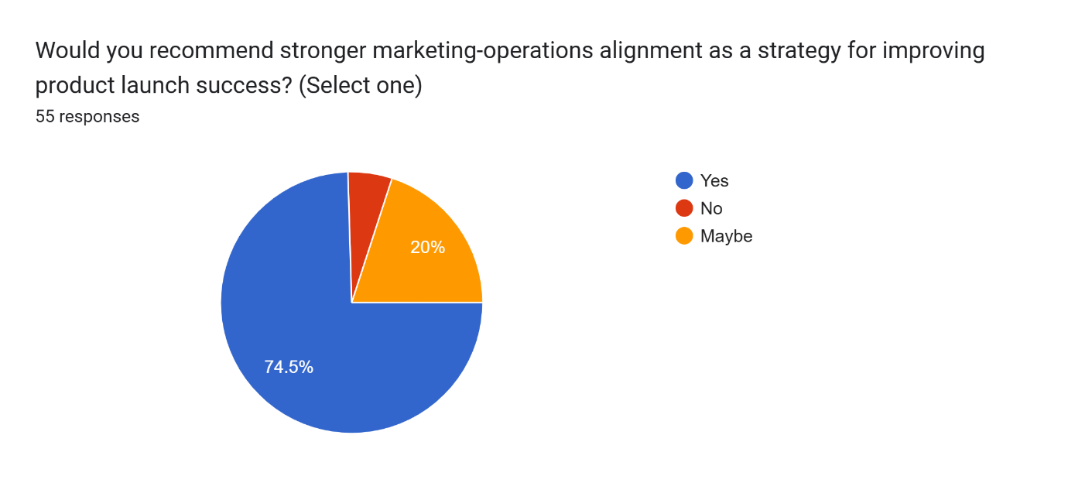

Interpretation

Marketing-Operations Alignment as a Key Strategy for Product Launch Success
The survey responses overwhelmingly indicate that stronger marketing-operations alignment is seen as a critical strategy for improving product launch success:
- 74.5% of respondents recommend stronger alignment.
- 20% are uncertain but acknowledge potential benefits.
- Only a small minority (5.5%) do not see it as a necessary strategy.

This means that the data reinforces the idea that effective collaboration between marketing and operations plays a pivotal role in :

Reducing product failures
- Improving time-to-market
- Enhancing demand forecasting & inventory management
- Boosting overall profitability

CHAPTER VII: RECOMMENDATIONS

Based on the findings of this study, several key recommendations are provided to help organizations effectively implement Coordination Between Marketing and Operations (MOA) and improve the success of introducing new products to the market. These recommendations focus on developing structured collaboration frameworks, enhancing leadership support, leveraging technology, optimizing resource allocation, and fostering an organizational culture that promotes cross-functional integration and efficiency.

Develop Clear and Structured MOA Frameworks
- Establish well-defined collaboration protocols between marketing and operations teams, outlining roles, responsibilities, and performance metrics.
- Standardized frameworks ensure seamless communication, prevent misalignment, and enhance cross-functional coordination throughout the product launch process.

Strengthen Leadership and Managerial Support
- Train marketing and operations leaders to effectively collaborate by aligning departmental goals, improving interdepartmental communication, and fostering a culture of shared accountability.
- Leadership should actively promote data-driven decision-making and cross-functional cooperation to minimize inefficiencies and ensure timely product launches.

Enhance Cross-Departmental Communication
- Implement regular strategy alignment meetings, shared dashboards, and integrated workflow systems to improve real-time coordination between teams.
- Encourage open communication channels to facilitate quick decision-making, problem-solving, and adaptability in dynamic market conditions.

Leverage Technology for Data-Driven Decision-Making
- Invest in Enterprise Resource Planning (ERP) systems, AI-driven demand forecasting tools, and real-time inventory management software to optimize marketing-operations synchronization.
- Use data analytics to track market trends, customer preferences, and supply chain performance, ensuring product launches are aligned with consumer demand.

Optimize Resource Allocation and Supply Chain Efficiency
- Ensure demand forecasts and production planning are aligned to prevent stockouts, reduce excess inventory, and improve supply chain responsiveness.
- Develop a flexible manufacturing and distribution model that allows for quick adjustments in production schedules and logistics planning based on real-time market feedback.
- Foster Trust and Accountability in Cross-Functional Teams
- Shift performance evaluation from individual department KPIs to shared success metrics, ensuring marketing and operations teams work toward common business objectives.
- Promote a collaborative work culture where both teams align on launch timelines, promotional strategies, and supply chain readiness to avoid bottlenecks.

Regularly Review and Improve MOA Strategies
- Conduct regular performance assessments, cross-functional team feedback sessions, and post-launch evaluations to identify gaps and areas for improvement in marketing-operations coordination.
- Continuously refine MOA strategies based on market trends, emerging technologies, and evolving consumer expectations to ensure long-term competitiveness and product success.

CHAPTER VIII: CONCLUSION

Coordination Between marketing-operations alignment (MOA) has emerged as a critical factor in ensuring the success of introducing new products to the market, improving market responsiveness, streamlining business processes, and overall business performance. This study examined the impact of MOA on product launch success, analyzing its benefits, challenges, and effectiveness in the sector of consumer products. The findings indicate that strong collaboration between marketing and operations teams leads to faster time-to-market, optimized inventory management, and higher customer satisfaction.

However, while MOA offers numerous advantages, its success depends on clear communication, leadership support, structured collaboration frameworks, and the integration of data-driven decision-making. Challenges such as misaligned departmental goals, inefficient resource allocation, and technological gaps must be addressed to maximize the benefits of marketing-operations integration. Organizations must also leverage digital tools and analytics-driven insights to improve demand forecasting, supply chain efficiency, and cross-functional coordination.

To ensure MOA remains effective and sustainable, companies should adopt a continuous improvement approach, regularly reviewing alignment strategies based on performance metrics, industry trends, and evolving consumer preferences. A culture of collaboration, transparency, and shared accountability is essential in fostering a seamless and efficient product launch process.

In conclusion, marketing-operations alignment is not just an operational necessity but a strategic imperative for consumer goods companies looking to achieve market leadership and long-term success. Organizations that prioritize teamwork across different departments, technological integration, and data-driven decision-making will be better positioned to optimize product launches, maximize profitability, and maintain a competitive edge in the dynamic consumer market.

REFERENCES / BIBLIOGRAPHY

- Swink, M., & Song, M. (2007). Effects of marketing-manufacturing integration on new product development time and competitive advantage. Journal of Operations Management, 25(1), 203-217.
- Ellinger, A. E., Keller, S. B., & Hansen, J. D. (2006). Bridging the divide between logistics and marketing: Facilitating collaborative behavior. Journal of Business Logistics, 27(2), 1-27.
- Griffin, A., & Hauser, J. R. (1996). Integrating R&D and marketing: A review and analysis of the literature. Journal of Product Innovation Management, 13(3), 191-215.
- Shapiro, B. P. (2002). Marketing and supply chain integration: A strategic perspective. Harvard Business Review, 80(6), 76-84.
- Hillebrand, B., Nijholt, J. J., & Nijssen, E. J. (2011). Marketing–manufacturing interface and its impact on innovation performance. Industrial Marketing Management, 40(8), 1151-1163.
- Kahn, K. B., & Mentzer, J. T. (1998). Marketing’s integration with other departments. Journal of Business Research, 42(1), 53-62.
- Roh, J., Hong, P., & Min, H. (2014). The impact of marketing-operations alignment on innovation and flexibility in supply chain operations. International Journal of Production Economics, 147, 124-135.
- Cooper, R. G., & Kleinschmidt, E. J. (1995). New product performance: Key drivers and success factors. Journal of Marketing Management, 11(4), 315-337.
- Slater, S. F., Hult, G. T. M., & Olson, E. M. (2010). Factors influencing the effectiveness of marketing-operations alignment in introducing new products to the market. Journal of the Academy of Marketing Science, 38(2), 239-252.
- Calantone, R. J., & Di Benedetto, C. A. (2000). Performance and time-to-market trade-offs in new product development. Journal of Product Innovation Management, 17(3), 217-234.
- Kotler, P., & Keller, K. L. (2016). Marketing Management (15th ed.). Pearson Education.
- Christopher, M. (2016). Logistics & Supply Chain Management (5th ed.). Pearson Education.
- Brown, S., & Blackmon, K. (2005). Aligning operations and marketing in product innovation. International Journal of Operations & Production Management, 25(4), 401-421.
- Choi, T. M., Wallace, S. W., & Wang, Y. (2018). Big data analytics in marketing-operations alignment: The role of predictive analytics in demand forecasting. Journal of Business Research, 90, 226-236.

APPENDIX/ ANNEXURE

Questionnaire: Impact of Marketing-Operations Alignment on New Product Launches in the Consumer Goods Industry

- Name: ________________________
- Email ID: ________________________
- What is your age group? (Select one)
  - 18-25
  - 26-35
  - 36-45
  - 46 and above
- What is your job role? (Select one)
  - Marketing Manager
  - Operations Manager
  - Supply Chain Professional
  - Product Development Executive
  - Other: _______________
- What industry segment do you work in? (Select one)
  - Fast-Moving Consumer Goods (FMCG)
  - Packaged Consumer Goods
  - Luxury Consumer Goods
  - Retail Consumer Products
  - Other: _______________
- How long have you been working in your current organization? (Select one)
  - Less than 1 year
  - 1-3 years
  - 4-6 years
  - More than 6 years
- How would you describe the level of alignment between marketing and operations teams in your organization? (Select one)
  - Strong and well-integrated
  - Moderate, with occasional misalignment
  - Weak, with frequent disconnects
  - No alignment at all
- How frequently do marketing and operations teams collaborate during a product launch? (Select one)
  - Throughout the entire process
  - Only at key milestones (e.g., planning, production, launch)
  - Rarely, mostly independent work
  - Not at all
- What are the biggest challenges in aligning marketing and operations in product launches? (Select one or more)
  - Lack of clear communication
  - Conflicting departmental priorities
  - Inaccurate demand forecasting
  - Supply chain and production constraints
  - Resistance to collaboration
  - No significant challenges
- How does your organization ensure coordination between marketing and operations? (Select one or more)
- Regular strategy alignment meetings
- Shared data dashboards and real-time analytics
- Collaborative project management tools
- Integrated performance metrics
- No formal alignment strategy
- How does marketing-operations alignment impact the success of new product launches in your organization? (Select one)
- Significantly improves success rates
- Somewhat improves success rates
- No significant impact
- Negatively affects success rates
- What benefits has your organization experienced from strong marketing-operations alignment? (Select one or more)
- Faster time-to-market
- Better demand forecasting and inventory management
- Higher customer satisfaction
- Improved cost efficiency
- Increased profitability
- No noticeable benefits
- If marketing and operations were better aligned in your company, what improvements would you expect in new product launches? (Select one or more)
- Shorter time-to-market
- Reduced product failures
- More accurate production planning
- Enhanced supply chain efficiency
- Stronger brand positioning
- Does your organization use technology to support marketing-operations alignment? (Select one)
- Yes, extensively
- Yes, but with limitations
- No, but planning to implement it
- No, not considered a priority
- What types of technologies does your organization use to support marketing-operations collaboration? (Select one or more)
- ERP (Enterprise Resource Planning) systems
- AI-driven demand forecasting tools
- Digital supply chain management platforms
- Real-time inventory tracking software
- Collaborative project management tools
- No technology is used
- What is the most common cause of marketing-operations misalignment in your organization? (Select one)
- Poor communication and lack of coordination
- Misaligned performance objectives
- Unclear demand forecasting and inventory management
- Budget constraints limiting cross-functional efforts
- Lack of leadership support for integration
- What would improve marketing-operations alignment in your company? (Select one or more)
- Clearer cross-functional collaboration frameworks
- More frequent communication and joint meetings
- Better technology integration
- Leadership initiatives promoting collaboration
- No improvements needed
- Would you recommend stronger marketing-operations alignment as a strategy for improving product launch success? (Select one)
- Yes
- No
- Maybe

Number of Responses Received = 55

